Residential Street

12 Design Elements
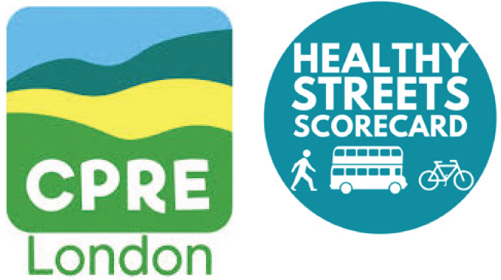
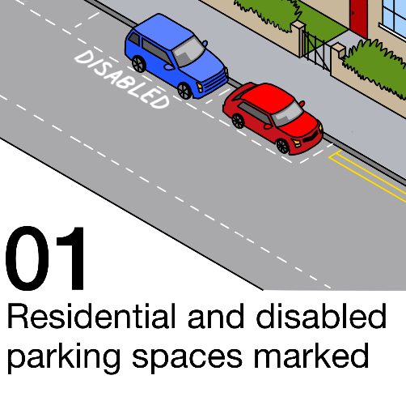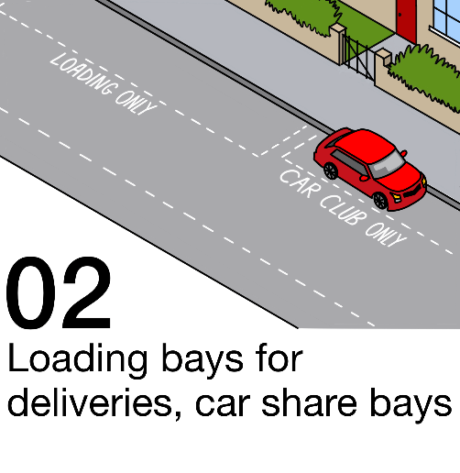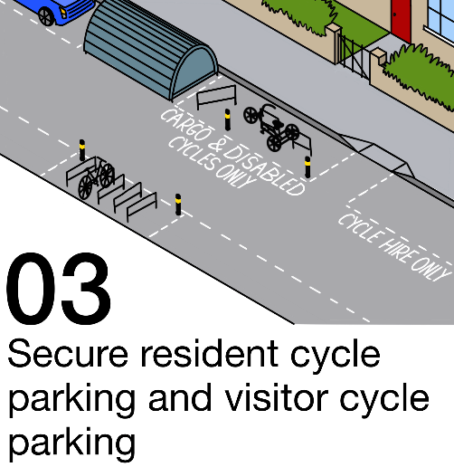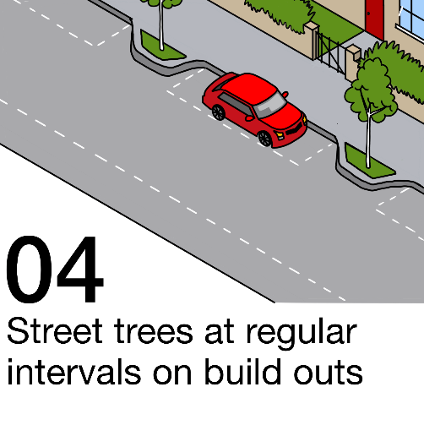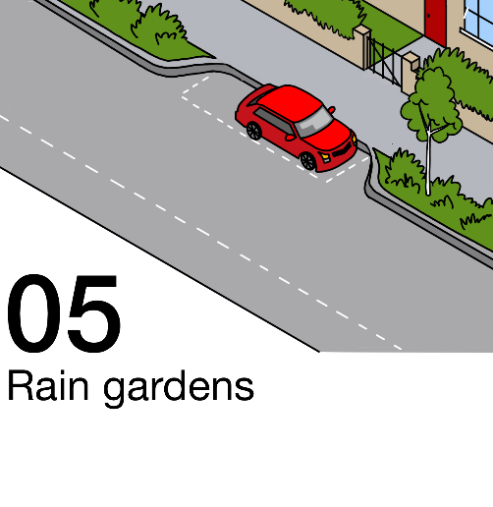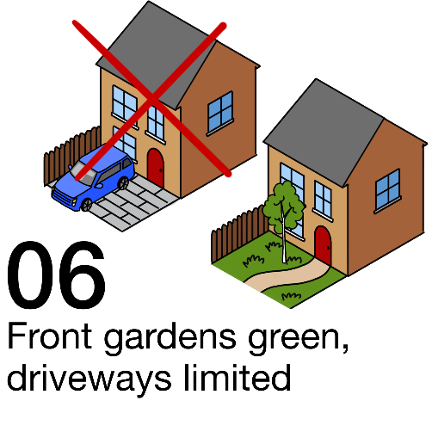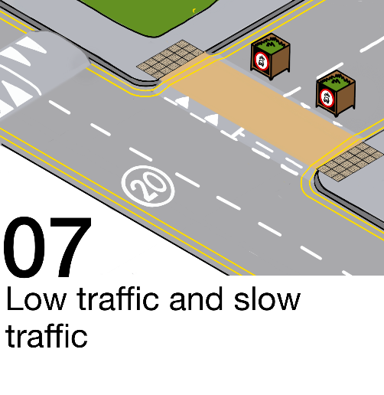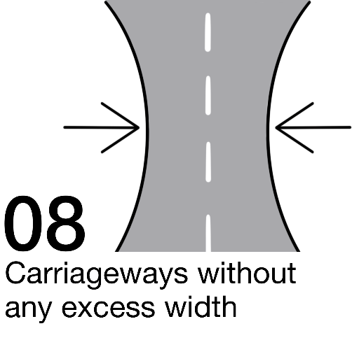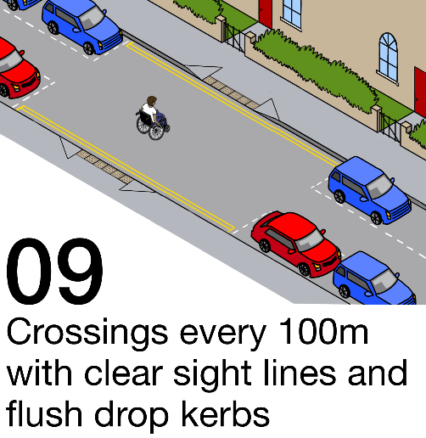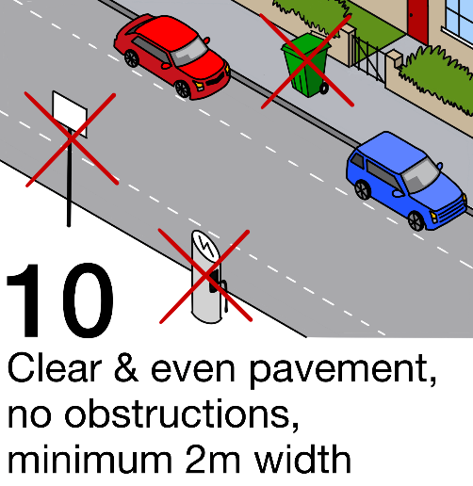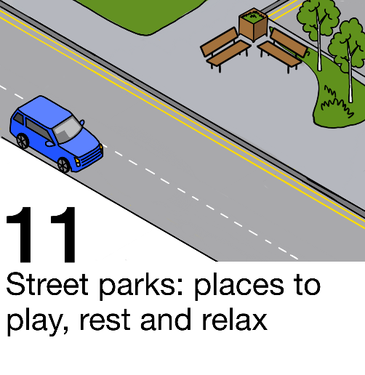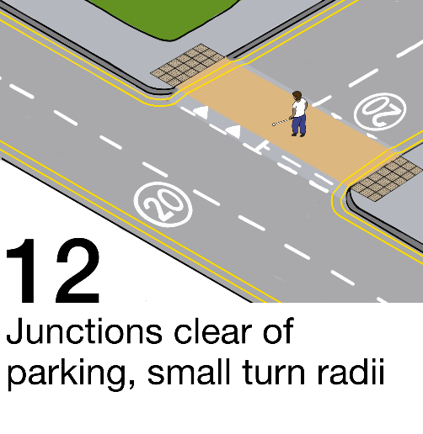

Twelve residential street design elements for Controlled Parking Zones or implementing kerbside strategy
- Resident and disabled parking spaces clearly marked as part of borough-wide, small-area Controlled Parking Zones.
- Loading bays for deliveries to avoid double parking and parking at junctions; car share bays to support a move away from car ownership.
- Secure cycle hangars, dockless cycle bays, visitor, disabled and cargo cycle stands to promote cycling, improve accessibility and avoid pavement obstruction.
- Street trees at regular intervals on build outs. Trees should be on buildouts or in rain gardens. Pavement should be built out around mature trees where they are causing an obstruction.
- Rain gardens to capture substantial rainwater and filter road run-off pollution.
- Front gardens green, driveways limited. Front gardens de-paved and re-greened. Illegal crossovers enforced. Pavement crossovers limited to reclaim public kerbside (disabled resident access needs accommodated appropriately).
- Low traffic. Borough-wide Low Traffic Neighbourhoods to support walking/wheeling, cycling, local buses and discourage car trips. Slow traffic. Borough-wide 20mph speed limits, chicanes, speed bumps and visual cues for speed control.
- Carriageways without any excess width to discourage speeding and reclaim space to use for wider pavements or to introduce other features outlined here.
- Crossings every 100m with clear sight lines and flush drop kerbs for safety and accessibility. 10m double yellow lines each side. Raised table and buildouts where possible.
- Clear and even pavement, no obstructions, 2m minimum width. Street clutter like EV charging points placed on carriageway buildouts. Parking sign posts shortened and placed close to garden walls.
- Street parks: places to play, rest and relax can be created by clearing cars from streets or sections of streets. Emergency and utility access can be retained if necessary.
- Junctions clear of parking, small corner turn radii to improve safety with better sight lines and lower driver speeds.
May 2025 hss@cprelondon.org.uk Design & illustrations: Amy Bradley @amybradleydesign

