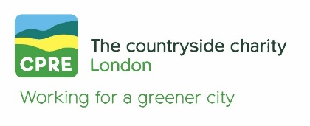
COMMERCIALISATION OF LONDON PARKS
Note prepared by Alice Roberts, Head of Campaigns, CPRE London; Andrew Smith, University of Westminster; Ed Allnutt, campaigner; Michael Lazarus Retired barrister and CPRE volunteer
October 2024
- Large-scale events in London’s parks: why we need better regulations

  - Policy makers and the public are now better informed about the benefits of providing accessible urban green spaces to assist citizens’ health and wellbeing. But London’s parks and green spaces are increasingly used as venues for large-scale, commercial events involving more than 20,000 attendees and there is an inherent conflict between the everyday use of green spaces, and large-scale events, the impact of which is varied, but the key issue is the public’s right to use London’s parks is eroded.

  - There has been an increase in the size and frequency of events in parks where events were already being held; but there has also been an expansion into other parks, not previously used for big events. Our research involving site visits and communications with park users suggests this issue has now reached a tipping point. What was previously happening in isolated parks is now a wider concern that is affecting a significant number of green spaces. The temporal and spatial footprints of large-scale events are contested across London: in the North (Finsbury Park); East (Victoria Park); South (Brockwell Park) and West (Gunnersbury Park). The issue is now affecting commons and open spaces too: for example, Clapham Common; Peckham Rye; Streatham Common; & Tooting Common. Tickets for these events are notoriously expensive, putting them out of reach of the majority of citizens. These are now exclusive events staged by global entertainment companies rather than public entertainments. (Read Dan Hancox’s research for more.)

  - We believe this trend is driven by two things: (1) A 2017 judgement in the Appeal Court meant councils no longer felt bound to adhere to rules which previously governed their activity. (2) Councils increasingly driven by financial pressures are more likely now to take advantage of that judgement.

- Why the current regulations are inadequate

  - The ‘Finsbury Park’ judgement in 2017 confirmed that local authorities have the right to hire out and enclose parks for events under section 145 of the Local Government Act 1972. But it also stated that constraints which councils had been adhering to prior to 2017, do not apply (notably the Greater London Parks and Open Spaces Act 1967 which limited the space which could be used for events to 10% or 1 acre). Effectively, there are now no constraints on how much of a park can be hired out, or for how long. [See Annex 1 for detail.]

  - In practice this has enabled bigger events at a time when councils are cash-strapped: some openly admit maximising revenue is now the primary motivation for large-scale events. At the same time, lack of constraints in the context of competition between councils makes it hard for them to impose restrictions on the companies running the events.

- What needs to happen now

  - Better regulation is needed to protect public access to parks and green spaces and prevent their over exploitation as commercial event venues. Councils do not own parks, they are the custodians of the public’s right to use them, and they must be provided for the benefit of the public. The expansion of expensive, fenced events undermines the ethos and accessibility of people’s parks. Placing clear constraints would also enable councils to set clear boundaries when negotiating with event companies.

  - Various efforts have been made to promote self-regulation:
- In 2017 Parks for London negotiated an agreement among London boroughs with as a kind of ‘code of conduct’.
- The University of Westminster’s 2020 report set out recommendations including that London-wide legislation should restricts paid entry events to a maximum amount of park space and park time should be revised and enforced.

  - However the recommendations are not adhered to. We believe this is because:
- Financial pressures on councils makes it difficult for them to manage what is a conflict of interest for them (custodians of public rights; a duty to balance budgets
- The grey area of what is / is not ‘reasonable’ allows global events companies to apply pressure when negotiating, and leaves councils competing with one another
- Councils are not well equipped to hold events companies to contracts for largescale events e.g. for damage to the park, litter, policing etc
- Councils are delegating to CICs to run events, and thereafter struggle to control the events (parks are then exploited by the CIC)

  - Measures need to be taken, in our view, to update, restore and enforce key elements of the 1967 Act, notably the temporal and spatial restrictions which provided reasonable measures to ensure commercial events could not dominate London’s parks and green spaces.
- The stipulation in the 1967 Act that events should not take up more than 10% or more than one acre (whichever is larger) of the available open space should be restored and enforced. Prior to the Haringey vs Friends of Finsbury Park rulings (2017), London Boroughs were adhering to this. This simple regulation has multiple benefits; it ensures the majority of park space remains accessible all year round, and it means that large-scale events have to be staged in suitably large parks.
- The stipulation in the 1967 Act regarding the permitted frequency of commercial event hires should be updated so that there is an agreed upper limit on: a) the number of days that local councils and park authorities can hire out parks and green spaces for large-scale events; and b) the number of days that park access can be disrupted by building and dismantling large-scale event venues.

These limits would prevent park authorities over-exploiting individual spaces and provide incentives for authorities to enforce shorter build up / break down phases.

EXAMPLE Tower Hamlets / Victoria Park / AEG
The new contract they have approved in early 2024 means a significant expansion in the number of major event days, potentially doubling them by 2026. The council expects to generate £1.588 million from commercial event activity in 2024, and the rationale for expansion includes the notion that they are competing with other councils and don't want to lose AEG contract. The event site is well over the 10% of the park areas as you can see from this map.

Image showing (the light grey areas) the scale of All Points East event in Victoria Park

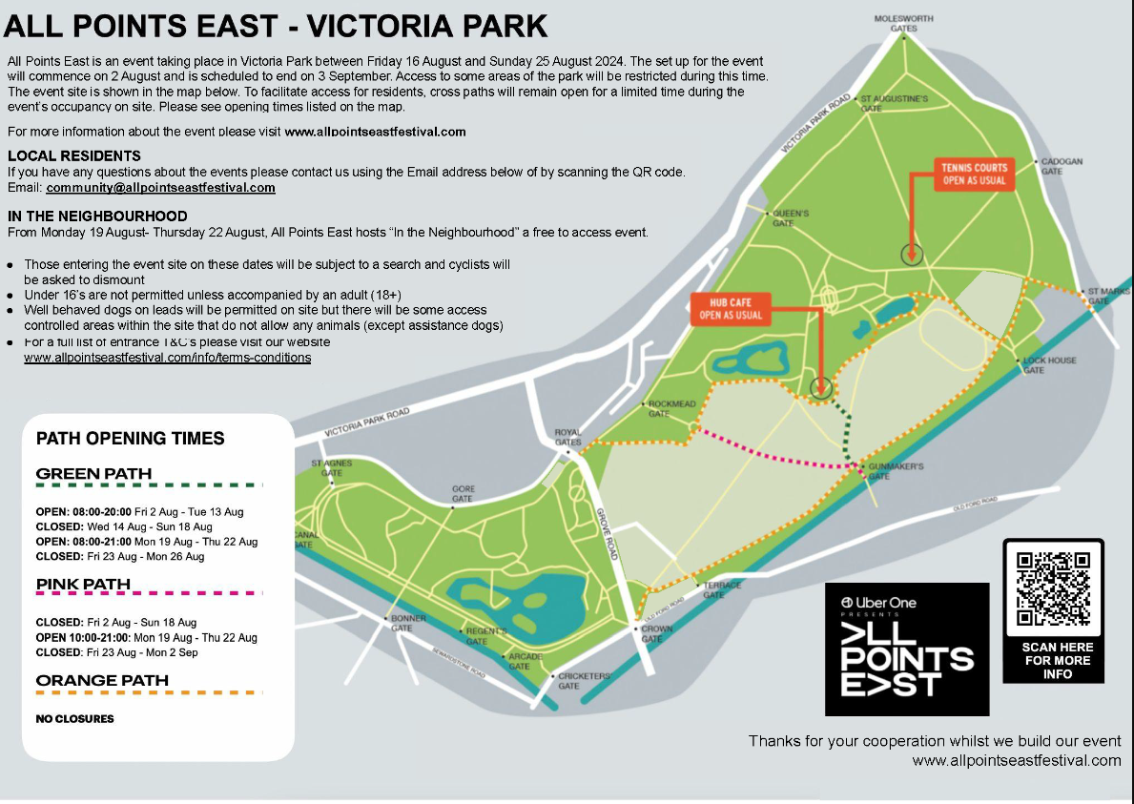

EXAMPLE Damage to Finsbury Park

This presentation from Louise Wass of the Friend of Finsbury Park gives an idea of the damage that can be done by major events. (If this link doesn’t work let me know I can send the file.)

Legislation and planning considerations governing time-limited commercialisation of public open space

The decision of the Court of Appeal in the Friends of Finsbury Park case [2017] EWCA Civ 1831 authoritatively dismissed various challenges to the interpretation of s.145 Local Government Act 1972 (LGA) which in essence, leaves that provision to be construed in accordance with its plain meaning.

S.145(2)(a) and (b) authorise a local authority to enclose or set apart any part of a park or pleasure ground owned or controlled by it for the purposes specified in s.145(1) and to permit any other person to use any such part of such open space on such terms as to payment or otherwise as the authority thinks fit and to authorise such person to make charges for admission.

S.145(1) authorises a local authority to do or arrange for the doing of anything necessary or expedient for (among other things) the provision of an entertainment of any nature and any purpose incidental to such entertainment including the provision of refreshments.

So in combination, ss.145(1) and (2) authorise a local authority to permit a third party to stage any kind of entertainment in any part of a park. The arrangements for such entertainment may include payment by the third party to the local authority and payment by the public to attend the entertainment. So the arrangements can be purely commercial in nature, similar to those between a concert hall owner, the promoters of the concert and concert goers.

Furthermore, the LGA places no limit on either the extent of the park or open space in which or the length of time during which such entertainment may be provided by local authorities or by third parties authorised by them. This contrasts with earlier statutes which imposed tight spatial (e.g. 1 acre or 10%) and temporal (e.g. 12 days per year or 4 consecutive days) limits.

Thus, on the face of the LGA, a local authority may deprive the public of access to the whole of any park on every day of the year to enable third parties to put on entertainments of any kind on a commercial basis. There is no requirement for the entertainment to be made available to the general public. For example, one of the entertainments taking place in Gunnersbury Park is only open to members of an exclusive (and expensive) members’ club.

The only restrictions on the, on the face of it, unfettered powers of local authorities under the LGA are the general limits which the courts place on the exercise by public bodies of discretionary powers known as the Wednesbury principles, namely requirements that the power should be exercised rationally, for a proper purpose and on a basis that takes account of all relevant considerations and does not take into account irrelevant considerations.

So for example, it may be hoped that a decision by a local authority to use the whole of a park as a year round commercial entertainment venue would be struck down by the court on Wednesbury grounds if the decision were challenged by way of Judicial Review.

But so far as we are aware, a decision of a local authority to permit part or all of a park to be used for entertainment has never been the subject of challenge on Wednesbury grounds. So it is impossible to predict how much of a park a local authority would need to let out for entertainment and for how long before the court would interfere.

It may be that the grounds on which such a decision could be challenged under Wednesbury principles could extend beyond consideration of the conflict between the proposed restriction of public access and the basic function of the relevant park as public open space. This could include broader considerations such as damage to the fabric of the park and the additional noise, crime, litter, anti-social behaviour and traffic caused by the entertainment in question in surrounding areas, factors which are frequently cited by local campaigners against the temporary commercialisation of public spaces.

Planning

It is also worth remembering that various licensing, planning and building regulations also apply to park event projects. Anything that will be in situ for more than 28 days needs planning permission. But permission is also required if the structure reaches a certain size (100m2) or covers more than 25% of the site.

Special and temporary structures where they can be interacted with by members of the public, including those in public areas, also need to comply with Part IV, Section 30 of the London Building Acts (Amendment) Act 1939.

These regulations also provide some degree of protection of the public interest.

Ministry of Housing and Local Government Provisional Order Confirmation (Greater London Parks and Open Spaces) Act 1967 Art 7(1)(ii) (the Provisional Order).
Public Health Acts (Amendment) Act 1890 s.44.
Note that a separate regime applies to commons under s.38 Commons Act 2006 which prohibits the erection of the type of structures and fencing normally required for large scale public entertainment on common land without the consent of the appropriate national authority. In Greater London, consent to exercise the powers under the Provisional Order may be obtained under Art 12 of that order, but such consent cannot authorise the enclosure of more than the greater of 1 acre or 10% of the common (see footnote 1 above).
https://www.visitgunnersbury.org/what-s-on/concerts-outdoor-events/soho-house-festival/
Associated Provincial Picture Houses v. Wednesbury Corporation [1948] 1 KB 223.

