Seb Dance
Deputy Mayor of London
Via email to: seb.dance@london.gov.uk
c.c. william.bradley@london.gov.uk
14 September 2022
Dear Seb,
Parking in London and on the TLRN
I hope that you will not mind my getting in touch. We were delighted to learn that you had been appointed Deputy Mayor for Transport but it has taken us a little while to make contact. As you may know, CPRE London led the London Boroughs Healthy Streets Scorecard project for the past three years.
Additionally, we have done a lot of work over the past two years to promote action on parking. Along with the other active travel groups, our interest in parking derives from the vast amount of public space taken up by it (at least 3000 hectares, roughly half of which is on street – Centre for London estimated on-street parking at 1400 hectares or the equivalent of 10 Hyde Parks) and the way that this space has often unconsciously and often at little cost to the user been ceded to car owners over the past 100 years. In the context of the climate crisis and the need to deliver healthy streets we believe that this space could and should be used to support these other agendas including much needed new ‘streetparks’, pocket parks, parklets, rain gardens, tree planting and other street infrastructure (which can be placed on build-outs, rather than on the pavement where they take space from pedestrians).
In 2020 we published Eight Ways to Transform Parking and Make London a Better Place which sets out the key issues around parking and outlines potential ways forward for both TfL and the boroughs
Restricting parking (removing it or charging for it) is the Number One way to promote sustainable modeshift – and we believe that, to meet the Mayor’s Transport Strategy modeshift targets, boroughs will need to take much more action on parking.
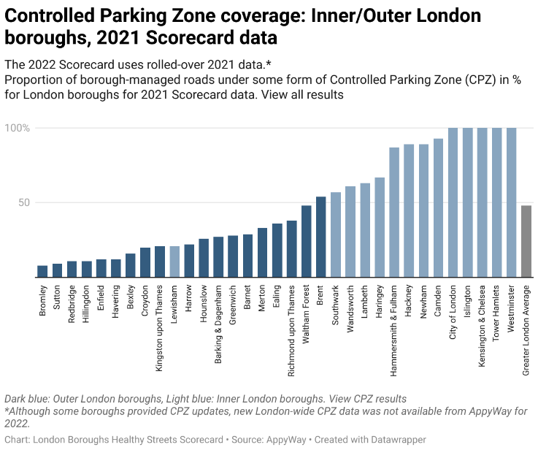
As part of the Healthy Streets Scorecard we publish data which shows a huge variation in the proportion of the boroughs’ streets with parking controls. In five boroughs, nearly 100% of streets have parking controls; by contrast in the Inner London borough of Lewisham just 21% of streets have controlled parking. Added to this, parking on Council Estates is rarely treated the same as on-street parking – in any borough.
These two issues are just examples of the relatively straightforward and cost-neutral parking related interventions which could have a dramatic impact on delivering MTS targets, pretty much overnight.

More recently, our concern that not enough emphasis is being placed on parking led us to publish the Local Authority Parking Policy Benchmark and Assessment Tool, to enable boroughs and local campaigners to easily identify areas for improvement. We are currently promoting that toolkit.
I’m writing now to ask you:
- Given the importance of parking policy, can LIP guidance do more to promote action on parking, specifically widening the use of controls for on-street and estate parking?
- Will TfL eliminate parking on the TLRN on all existing bus routes and where new bus or cycle priority is needed.
- Will TfL remove the frequent practice of vehicles being allowed to drive over the pavement (from TLRN roads) to access parking in front of shops etc (this issue has been raised with the Walking and Cycling Commissioner)?
- Will TfL encourage boroughs to propose changes to parking on the TLRN to promote bus and cycle priority and promote better town centres and high streets e.g. by promoting the removal of bays on main roads (placing them instead on side-streets)?
- Will TfL enable boroughs to manage Controlled Parking Zones on the TLRN so parking is not free?
- Will TfL take immediate action to implement double yellow (red!) lines where parking on the TLRN is currently uncontrolled e.g. on the A10 Evering Road between Leswin Rd and Manse Rd.
I look forward to hearing from you on this important issue and would be happy to meet to discuss this issue either as CPRE London or with colleagues from the Healthy Streets Scorecard coalition
Yours sincerely
Alice Roberts
Head of Campaigns, CPRE London
alice@cprelondon.org.uk
07792942691

