London Borough of Bromley
By email to: csc@bromley.gov.uk
c.c. Cllr William Hungtindon-Thresher william@ocat.co.uk
5 January 2021

Dear Sirs,

Bromley Open Spaces Strategy consultation response

Thank you for the opportunity to respond to this important consultation. CPRE London is a membership-based charity with 2,500 members across London. We work to protect and enhance London’s green spaces and promote a sustainable urban environment.

We are very concerned about the draft Open Space Strategy, a central aim of which is to identify green spaces ‘for development or disposal’. We strongly object to the Open Space Strategy’s central aim to build on and/or dispose of green space and urge that the council does not agree any document with these aims. In several places, the draft strategy contains actions aimed at getting rid of open spaces:
- At the outset there is a statement that one of the challenges will be “Being brave enough to recognise when open space should be repurposed.”
- SO1 action is to “Identify open spaces that require alteration, investment or reassignment including development or disposal” (and “Identification of an optimal portfolio model and creative use of open space assets” – a statement which could mean a number of things but to us is very worrying)
- SO2 action is to “Develop proven solutions to the use of assets for commercial, leisure and non-traditional activities.”
- SO4 is to “Investigate repurposing proposed urban centre open spaces to support the local economy” and “identify opportunities to enhance the open space portfolio facilities through alignment with the local economy.”

There is no need to ‘dispose’ or ‘develop’ green spaces. There is plenty of space to build – alternative sites are available. The motivations behind the ‘development and disposal’ of green /open spaces have not been made clear. Should the borough be concerned to find space to deliver housing or other development, there are other options which could and should be considered, for example, there are large amounts of grey space given to car parking, roads or indeed buildings which could be redeveloped.

‘Poor quality’ space or ‘not well-used’ space is NOT a reason to get rid of green space. There are references to assessments of space without any indication of the potential for the improvement of these spaces. Where spaces are regarded as poor quality or where it is felt ‘these are poor spaces not well used’ – we would argue this is mainly because no investment has taken place either through benign neglect or deliberately: this is not a reason to get rid of green space.

The “Gap analysis of open space amenities and facilities” (SO1) strategy must be based on the expected increased population, and on regional needs e.g. for sports pitches etc, and must take account of the fact that much of Bromley already has less greenspace that is needed for the population. Given the population is set to grow, all efforts should be made to retain green space to ensure the growing population’s needs are served. Any assessment of need should be made with reference to Green Space Standards.

See Fields in Trust Green Space Index | Fields in Trust – see the map pasted below where the light brown is areas which are below the standard.

The Fields in Trust ‘Green Space Index’ map shows (in yellow) areas where provision is less than the minimum standard
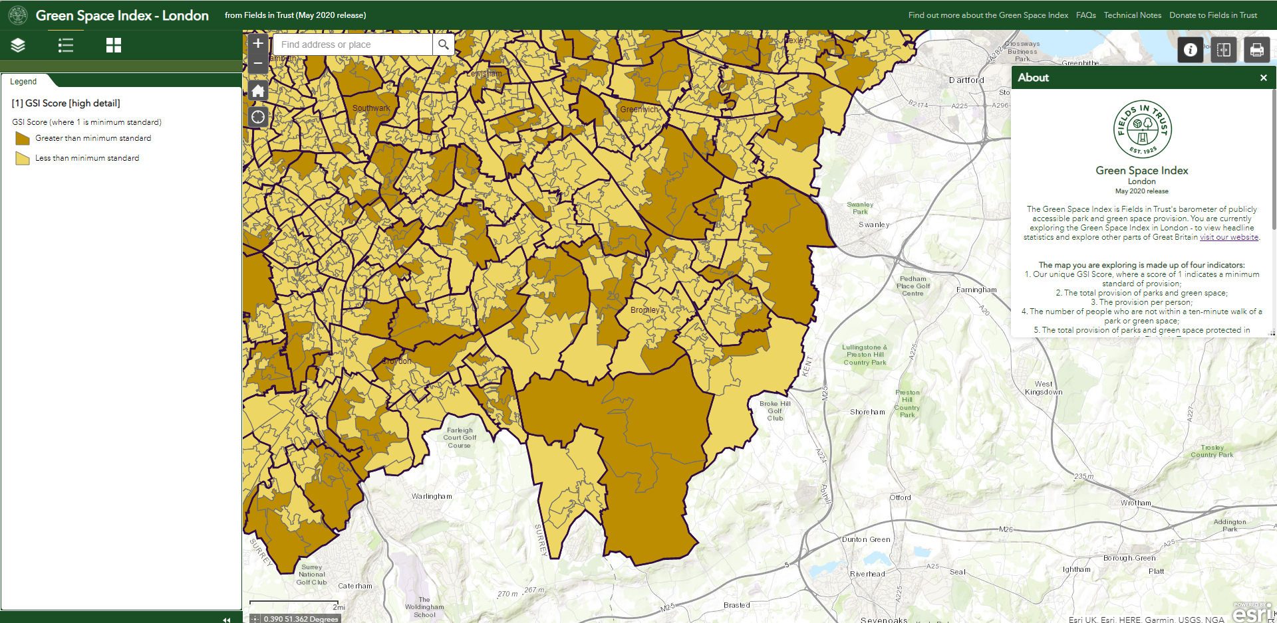

Green Towns – it is not clear what these are so we cannot comment on whether they are to be supported or not. The document mentions ‘green town’ models but does not clarify what this means. This is not a term we are familiar with nor have we found any reference to it by searching the internet. For 2022/23 “create a ‘green town’ model programme and initiate pilot projects at Church House Gardens, Queens Gardens, Library Gardens, Martin Hill, Queensmead, Palace Park and College Green” (we note from the Bromley Local Plan that all these sites are designated as Local Green Space and have planning protection).

Clearly Bromley Council is, like all boroughs, the custodian of green spaces and we would not expect any borough, Bromley included, to regard its vital green spaces as assets to be disposed of.

Thank you once again for providing the opportunity to respond to this important consultation.

I would be grateful if you could acknowledge safe receipt of this letter.

Yours faithfully
Alice Roberts
Head of Campaigns
CPRE London
alice@cprelondon.org.uk
07792942691

