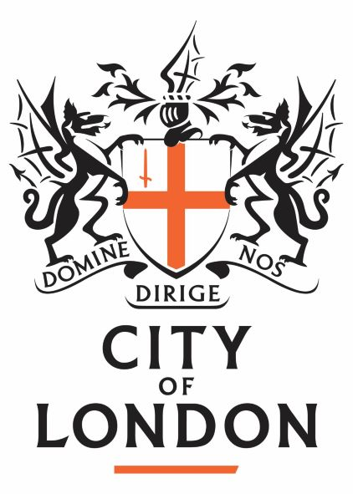

FOR IMMEDIATE RELEASE: Thursday 23 May
For more information contact Alice Roberts on 07792942691

London Parks Consortium to launch a Big Green London Map

The City of London Corporation’s charitable funder, City Bridge Trust[1] and CPRE London[2] are delighted to announce today, Thursday 23 May, that a consortium led by CPRE London will receive funding for a three year project to launch a web-based Big Green London Map.

The map will bring together and promote various listings and information for London’s 3000 public parks and green spaces with the ultimate aim of listing and promoting all of them as well as the many thousands of other valuable green sites across London too.

Alice Roberts of CPRE London said:

“This will allow us to, literally, put London’s green spaces on the map. Unlike other popular online maps, it will show all our parks, however small, and will let you find out what’s going on in a park, whether it’s something for the kids, or a ‘dementia walk’, a community fun day, a Park Run, organised or informal sports, a café, whatever.”

“Our project will help Londoners get more out of their parks. It will also promote the involvement of ‘friends groups’ in the care and management of parks because they help improve the park, lobby for better facilities or even run community events, all of which ensure people get the most out of their local green space.”

Dhruv Patel, Chairman of City Bridge Trust, said:

“This map is a great way to highlight what’s on offer so Londoners can make the best use of the capital’s parks.

“These sites are the lungs of London. They’re good for mental health, sitting at the very heart of our communities, and providing the chance to get away from busy city life.

“Tackling disadvantage and inequality across the capital is essential to making London a fairer and better place in which to live.”

CPRE London has joined forces with the London Friends of Green Spaces Network[3], Greenspace Information for Greater London CIC (the capital’s Environmental Records Centre)[4] Revolution Consultancy and Design[5]; and the campaign to make London the world’s first National Park City[6] to launch the project.

Parks Friends and community groups will be helping to maintain the map and give it a local feel, and Londoners will be able to find out more about what’s happening in their local park by clicking through to their local Park Friends group website or social media posts.

The map will be launched as part of the launch of the London National Park City in July 2019[7].

ENDS

- City Bridge Trust launched the www.parklifelondon.org with excellent information on London’s parks and now wants to work with the London Parks Consortium to ensure all Londoners can get the most out of their parks and green spaces.
- CPRE London (www.cprelondon.org.uk) has run its award-winning #GoParksLondon campaign, with a map and campaign ‘microsite’ at www.GoParks.London since July 2018, promoting parks, their friends groups and volunteering opportunities, including producing and promoting short films about friends groups at https://www.youtube.com/channel/UCgB6_gso82O7rFeLfX6opIg/videos
- London Friends of Greenspaces Network supports and promotes London’s park friends groups by sharing information via its bulletins/website and running networking events.
- Greenspace Information for Greater London CIC (GiGL) (the capital’s local environmental records centre) has published its Discover London Map (http://discover-london.gigl.org.uk/) and promotes this. The information displayed relates to publicly accessible sites including the Public Open Space hierarchy and Sites of Importance for Nature Conservation. It is underpinned by data generated via the London Habitat Survey, individual GiGL Partners and other stakeholders and has a ‘Sites to Visit’ layer.
- Revolution Consultancy & Design are the consoritum’s digital and geospatial solutions partner, providing community and map-driven solutions delivered through their Forward Movement Platform, enabling smarter and more engaging interactions.
- London National Park City London National Park City is a place, a vision and a movement to improve life in London by working with and helping residents, visitors and partners to enjoy London’s great outdoors more; make the city greener, healthier and wilder; and, to promote London’s identity as a National Park City. In July, London becomes the world’s first National Park City with a major Summit, a crowd-funded National Park City Maker newspaper, a week-long festival with over 200 events. http://www.nationalparkcity.london/
- http://www.nationalparkcity.london/launch

